SMART HEALTH MONITORING SYSTEM FOR ELDERLY PEOPLE USING IBM IOT PLATFORM

A health monitoring system for elderly people to check their temperature and pulse rate. Through Mobile App, the concerned people can get the status of health including Doctor.

ABSTRACT:

This project is to design a system for monitoring the health status of elderly people at any time using the internet connectivity. The person is equipped with a wearable device in favour of monitoring his/her temperature levels and pulse rate. The wearable device is connected to the Mobile App where the patient can log in to know their health status. Through Mobile App, the concerned people can get the status of health including Doctor. Monitoring and Recording of various medical parameters of patient outside hospitals has become Widespread phenomenon. The function of this system is to measure some biological parameter of the patient’s body like Temperature, Pulse rate by using sensors and the sensors will sense the body temperature, pulse rate of the patient and sends the values to IoT Cloud platform through WIFI-Module. All information about the patient health will be stored on the cloud, it enables the doctors to monitor patient’s health, where the doctor can continuously monitor the patient’s condition on his Smart phone.

INTRODUCTION:

Internet of Things can be determined as connecting everyday things embedded with electronics, software and sensors to internet enabling them to collect and exchange data. In the traditional approach the healthcare professionals play the major role. They need to visit the patient’s ward for necessary diagnosis and advising. There are two basic problems associated with this approach. Firstly, the healthcare professionals must be present on site of the patient all the time and secondly, the patient remains admitted in a hospital, bedside biomedical instruments, for a period of time. In order to solve these two problems, the patients are given knowledge and information about disease diagnosis and prevention. Secondly, a reliable and readily available health monitoring system is required. In order to improve the above condition, we can make use of technology in a smarter way. In recent years, health care sensors along with raspberry pi play a vital role. Wearable sensors are in contact with the human body and monitor his or her physiological parameters. We can buy variety of sensors in the market today such as ECG sensors, temperature sensors, pulse monitors etc. The cost of the sensors varies according to their size, flexibility and accuracy.

IoT Architecture:

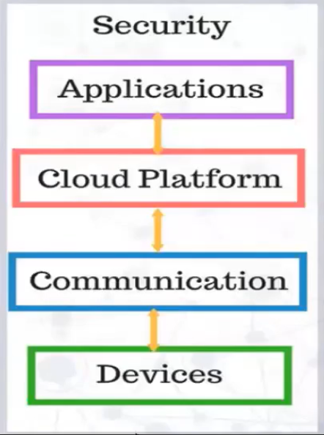

Security should be maintained in all the above levels, here the device is the controller and it senses the values by using some sensors. The sensor values will be sent to the cloud platform using communication which might be “device to device” or “device to cloud” communications

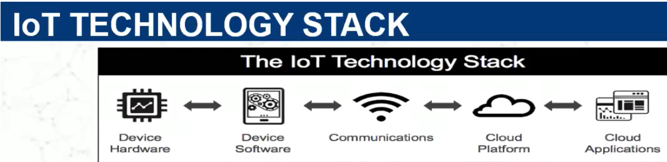

In smart health monitoring system, we use “device to cloud” communication by using certain http protocols to send the data from device to cloud. After storing the data in cloud, we need to retrieve it and send to applications to view the data

Objectives:

* Internet of Things (IoT) is the emerging technology, which contains huge amount of smart object and smart devices connected to the internet for communicating with each other.
* The final results are displayed on the android device, on web server and also the results are sent to the user through SMS.
* These data results can be stored in data base centre which can be invoked from remote location at any time in an emergency case of patient without delaying the time.
* This project may play vital role in saving the patient life at emergency time since “Time is life”

Advantages of Smart-health monitoring system:

1. **Remote monitoring**: Real-time remote monitoring via connected IoT devices and smart alerts can diagnose illnesses, treat diseases and save lives in case of a medical emergency.
2. **Prevention**: Smart sensors analyse health conditions, lifestyle choices and the environment and recommend preventative measures, which will reduce the occurrence of diseases and acute states.
3. **Reduction of healthcare costs**: IoT reduces costly visits to doctors and hospital admissions and makes testing more affordable.
4. **Medical data accessibility**: Accessibility of electronic medical records allow patients to receive quality care and help healthcare providers make the right medical decisions and prevent complications.
5. **Improved treatment management**: IoT devices help track the administration of drugs and the response to the treatment and reduce medical error.

**DISADVANTAGES**:

1. **Security and privacy**: Security and privacy remain a major concern deterring users from using IoT technology for medical purposes, as health care sections have the potential to be breached or hacked. The leak of sensitive information about the patient’s health and location and meddling with sensor data can have grave consequences, which would counter the benefits of IoT.
2. **Risk of failure**: Failure or bugs in the hardware or even power failure can impact the performance of sensors and connected equipment placing healthcare operations at risk. In addition, skipping a scheduled software update may be even more hazardous than skipping a doctor check-up.
3. **Integration**: There’s no consensus regarding IoT protocols and standards, so devices produced by different manufacturers may not work well together. The lack of uniformity prevents full-scale integration of IoT, therefore limiting its potential effectiveness.

**Applications**:

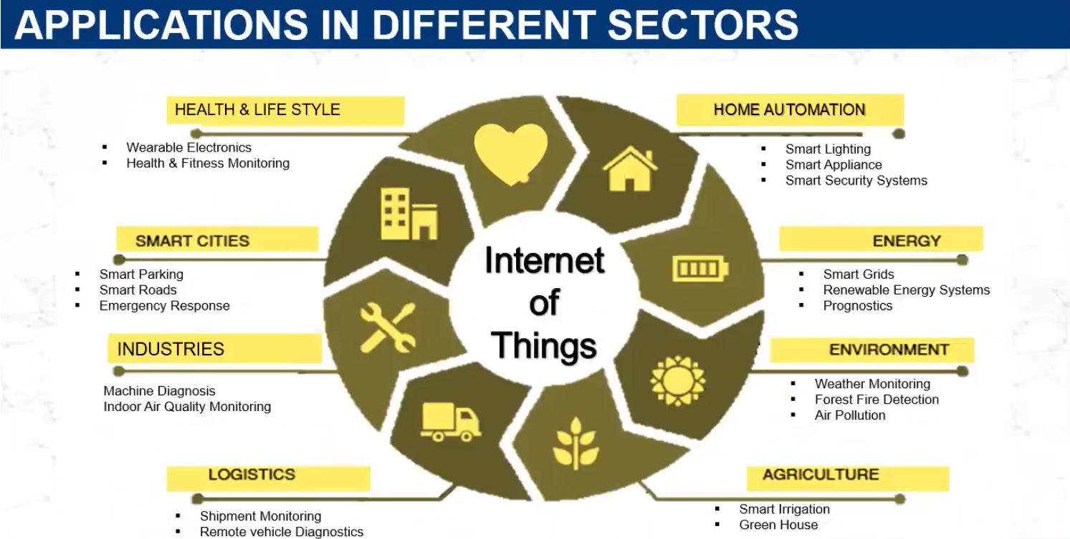

Future scope:

The present generation in search of employment sources are migrating to other places and it became very difficult to take care of elderly people’s health. This project aims at developing the smart health monitoring system using IoT technology with an objective of taking care of elderly people. The current society needs such type of smart inventions. According to a report, the market for IoT healthcare technology will rise to $400 billion by 2022. Such growth will be due to the increasing demand, the improvement of 5G connectivity and IoT technology and the growing acceptance of healthcare IT software. The plans of tech giants like Apple, Google and Samsung to invest in bridging the gap between fitness tracking apps and actual medical care are sure to contribute to the process too.